**An Overview of Wireless Systems**

Introduction

The cellular system employs a different design approach than most commercial radio and television systems use. Radio and television systems typically operate at maximum power and with the tallest antennas allowed by the regulatory agency of the country. In the cellular system, the service area is divided into cells. A transmitter is designed to serve an individual cell. The system seeks to make efﬁcient use of available channels by using low-power transmitters to allow frequency reuse at much smaller distances. Maximizing the number of times each channel can be reused in a given geographic area is the key to an efﬁcient cellular system design.

Wireless systems consist of wireless wide-area networks (WWAN) [i.e., cellular systems], wireless local area networks (WLAN), and wireless personal area networks (WPAN) (see Figure 1 below). The handsets used in all of these systems possess complex functionality, yet they have become small, low power consuming devices that are mass produced at a low cost, which has in turn accelerated their widespread use. The recent advancements in Internet technology have increased network trafﬁc considerably, resulting in a rapid growth of data rates. This phenomenon has also had an impact on mobile systems, resulting in The extraordinary growth of the mobile Internet.

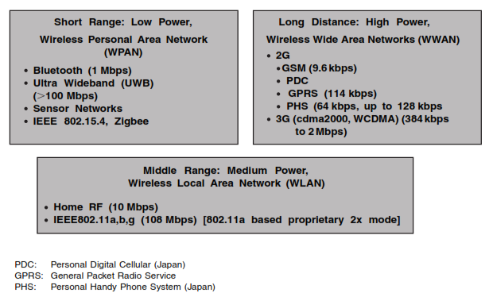

Figure 1

We will discuss brieﬂy 1G, 2G, 2.5G, and 3G cellular systems and also introduce broadband (4G) systems, which are aimed on integrating WWAN, WLAN, and WPAN.

First- and Second-Generation Cellular Systems

The ﬁrst and second-generation cellular systems are the WWAN. The ﬁrst public cellular telephone system (ﬁrst-generation, 1G), called Advanced Mobile Phone System (AMPS), was introduced in 1979 in the United States. During the early 1980s, several incompatible cellular systems (TACS, NMT, C450, etc.) were introduced in Western Europe. The deployment of these incompatible systems resulted in mobile phones being designed for one system that could not be used with another system, and roaming between the many countries of Europe was not possible. The ﬁrst-generation systems were designed for voice applications. Analog frequency modulation (FM) technology was used for radio transmission.

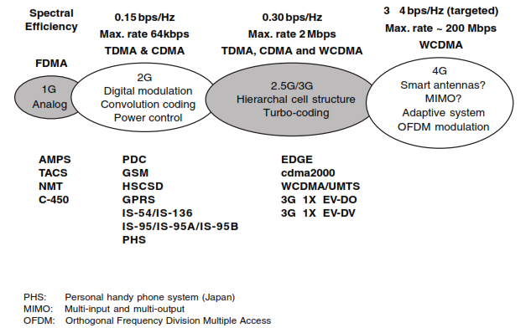

Figure 2 Wireless network from 1G to 4G

In 1982, the main governing body of the European post telegraph and telephone (PTT), la Conférence européenne des Administrations des postes et des télécommunications (CEPT), set up a committee known as Groupe Special Mobile (GSM). The GSM was renamed Global System for Mobile communications. The early years of the GSM were devoted mainly to the selection of radio technologies for the air interface.

The interfaces, protocols, and protocol stacks in GSM are aligned with the Open System Interconnection (OSI) principles. The GSM architecture is an open architecture which provides maximum independence between network elements such as the Base Station Controller (BSC), the Mobile Switching Center (MSC), the Home Location Register (HLR), etc. This approach simpliﬁes the design, testing, and implementation of the system. It also favors an evolutionary growth path, since network element independence implies that modiﬁcation to one network element can be made with minimum or no impact on the others. Also, a system operator has the choice of using network elements from different manufacturers.

GSM 900 (i.e., GSM system at 900 MHz) was adopted in many countries, including the major parts of Europe, North Africa, the Middle East, many east Asian countries, and Australia. The adaptation of GSM at 1800 MHz (GSM 1800) also spreads coverage to some additional east Asian countries and some South American countries. GSM at 1900 MHz (i.e., GSM 1900), a derivative of GSM for North America, Covers a substantial area of the United States. All of these systems enjoy a form of roaming, referred to as Subscriber Identity Module (SIM) roaming, between them and with all other GSM-based systems. A subscriber from any of these systems could access telecommunication services by using the personal SIM card in a handset suitable to the network from which coverage is provided. If the subscriber has a multiband phone, then one phone could be used worldwide. The Personal Communications Services (PCS) offers multimedia services (i.e., voice, data, video, etc.) at anytime and anywhere. With a three band handset (900, 1800, and 1900 MHz), true worldwide seamless roaming was possible. GSM 900, GSM 1800, and GSM 1900 are second-generation (2G) systems and belong to the GSM family. Cordless Telephony 2 (CT2) is also a 2G system used in Europe for low mobility.

Two digital technologies, Time Division Multiple Access (TDMA) and Code Division Multiple Access (CDMA) emerged as clear choices for the newer PCS systems. TDMA is a narrowband technology in which communication channels on a carrier frequency are apportioned by time slots. For TDMA technology, there are three prevalent 2G systems: North America TIA/EIA/IS-136, Japanese Personal Digital Cellular (PDC), and European Telecommunications Standards Institute (ETSI) Digital Cellular System 1800 (GSM 1800), a derivative of GSM. Another 2G system based on CDMA (TIA/EIA/IS-95) is a direct sequence (DS) spread spectrum (SS) system in which the entire bandwidth of the carrier channel is made available to each user simultaneously. The bandwidth is many times larger than the bandwidth required to Transmit the basic information. CDMA systems are limited by interference produced by the signals of other users transmitting within the same bandwidth.

The major markets for CDMA technology are North America, Latin America, and Asia, in particular Japan and Korea. In total, CDMA has been adopted by many countries around the world. The reasons behind the success of CDMA are obvious. CDMA is an advanced digital cellular technology, which can offer six to eight times the capacity of analog technologies (AMP) and up to four times the capacity of digital technologies such as TDMA. The speech quality provided by CDMA systems is far superior to any other digital cellular system, particularly in difﬁcult RF environments such as dense urban areas and mountainous regions. In both initial deployment and long-term operation, CDMA provides the most cost effective solution for cellular operators. CDMA technology is constantly evolving to offer customers new and advanced services. The mobile data rates offered through CDMA phones have increased and new voice codecs provide speech quality close to the ﬁxed wireline. Internet access is now available through CDMA handsets. Most important, the CDMA network offers operators a smooth migration path to third-generation (3G) mobile systems.

**Cellular Communications from 1G to 3G**

Mobile systems have seen a change of generation, from ﬁrst to second to third, every ten years or so (see Figure 3 below). At the introduction of 1G services, the mobile device was large in size, and would only ﬁt in the trunk of a car. All analog components such as the power ampliﬁer, synthesizer, and shared antenna equipment were bulky. 1G systems were intended to provide voice service and low rate (about 9.6 kbps) circuit-switched data services. Miniaturization of mobile devices progressed before the introduction of 2G services (1990) to the point where the size of mobile phones fell below 200 cubic centimeters (cc). The ﬁrst-generation handsets provided poor voice quality, low talk-time, and low standby time. The 1G systems used Frequency Division

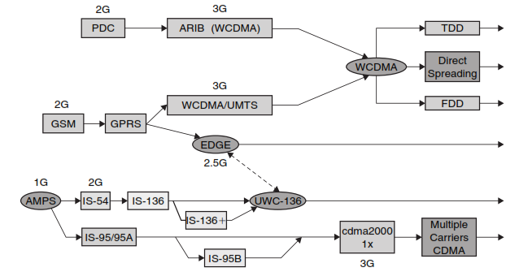

Figure 3 Cellular networks (WWAN) evolution from 1G to 3G

Multiple Access (FDMA) technology and analog Frequency Modulation (FM).

The 2G systems based on TDMA and CDMA technologies were primarily designed to improve voice quality and provide a set of rich voice features. These systems supported low rate data services (16–32 kbps). For second-generation systems three major problems impacting system cost

and quality of service remained unsolved. These include what method to use for band compression of voice, whether to use a linear or nonlinear modulation scheme, and how to deal with the issue of multipath delay spread caused by multipath propagation of radio waves in which there may not only be phase cancellation but also a signiﬁcant time difference between the direct and reﬂected waves.

Large increases in the numbers of cellular subscribers and the worries of exhausting spectrum resources led to the choice of linear modulation systems. To deal with multipath delay spread, Europe, the United States, and Japan took very different approaches. Europe adopted a high transmission rate of 280 kbps per 200 kHz RF channel in GSM using a multiplexed TDMA system with 8 to 16 voice channels, and a mandatory equalizer with a high number of taps to overcome inter-symbol interference (ISI). The United States used the carrier transmission rate of 48 kbps in 30 kHz channel, and selected digital advanced mobile phone (DAMP) systems (IS-54/IS-136) to reduce the computational requirements for equalization, and the CDMA system (IS-95) to avoid the need for equalization. In Japan the rate of 42 kbps in 25 kHz channel was used, and equalizers were made optional. Taking into account the limitations imposed by the ﬁnite amount of radio spectrum available, the focus of the third-generation (3G) mobile systems has been on the economy of network and radio transmission design to provide seamless service from the customers’ perspective. The third-generation systems provide their users with seamless access to the ﬁxed data network. They are perceived as the wireless extension of future ﬁxed networks, as well as an integrated part of the ﬁxed network infrastructure. 3G systems are intended to provide multimedia services including voice, data, and video.

One major distinction of 3G systems relative to 2G systems is the hierarchical cell structure designed to support a wide range of multimedia broadband services within the various cell types by using advanced transmission and protocol technologies. The 2G systems mainly use one-type cell and employ frequency reuse within adjacent cells in such a way that each single cell manages its own radio zone and radio circuit control within the mobile network, including trafﬁc management and handoff procedures. The trafﬁc supported in each cell is ﬁxed because of frequency limitations and little ﬂexibility of radio transmission which is mainly optimized for voice and low data rate transmissions. Increasing trafﬁc leads to costly cellular reconﬁguration such as cell splitting and cell sectorization. The multilayer cell structure in 3G systems aims to overcome these problems by overlaying, discontinuously, pico- and microcells over the macrocell structure with wide area coverage. Global/satellite cells can be used in the same sense by providing area coverage where macrocell constellations are not economical to deploy and/or support long distance trafﬁc.

CDMA is the selected approach for 3G systems by the ETSI, ARIB (Association of Radio Industries and Business — Japan) and Telecommunications Industry Association (TIA). In Europe and Japan, Wideband CDMA (WCDMA/UMTS [Universal Mobile Telecommunication Services]) was selected to avoid IS-95 intellectual property rights. In North America, cdma2000 uses a CDMA air-interface based on the existing IS-95 standard to provide wireline quality voice service and high speed data services at 144 kbps for mobile users, 384 kbps for pedestrians, and

2 Mbps for stationary users. The 64 kbps data capability of CDMA IS-95B provides high speed Internet access in a mobile environment, a capability that cannot be matched by other narrowband digital technologies. Mobile data rates up to 2 Mbps are possible using wide band CDMA technologies. These services are provided without degrading the systems’ voice transmission

Capabilities or requiring additional spectrum. This has tremendous implications for the majority of operators that are spectrum constrained. In the meantime, DSPs have improved in speed by an order of magnitude in each generation, from 4 MIPs (million instructions per second) through 40 MIPs to 400 MIPs.

Since the introduction of 2G systems, the base station has seen the introduction of features such as dynamic channel assignment. In addition, most base stations began making shared use of power ampliﬁers and linear amplifiers whether or not modulation was linear. As such there has been an increasing demand for high-efﬁciency, large linear power ampliﬁers instead of nonlinear ampliﬁers. At the beginning of 2G, users were fortunate if they were able to obtain a mobile device below 150 cc. Today, about 10 years later, mobile phone size has reached as low as 70 cc. Furthermore, the enormous increase in very large system integration (VLSI) and improved CPU performance has led to increased functionality in the handset, setting the path toward becoming a small-scale computer.

Road Map for Higher Data Rate Capability in 3G

The ﬁrst- and second-generation cellular systems were primarily designed for voice services and their data capabilities were limited. Wireless systems have since been evolving to provide broadband data rate capability as well. GSM has moved forward in developing cutting-edge, customer-focused solutions to meet the challenges of the 21st century and 3G mobile services. When GSM was ﬁrst designed, no one could have predicted the dramatic growth of the Internet and the rising demand for multimedia services. These developments have brought about new challenges to the world of GSM. For GSM operators, the Emphasis is now rapidly changing from that of instigating and driving the development of technology to fundamentally enable mobile data transmission to that of improving speed, quality, simplicity, coverage, and reliability in terms of tools and services that will boost mass market take-up. People are increasingly looking to gain access to information and services whenever they want from wherever they are. GSM will provide that connectivity. The combination of Internet access, web browsing, and the whole range of mobile multimedia capability is the major driver for development of higher data speed technologies.

GSM operators had two options for evolving their networks to 3G wide band multimedia operation: (1) they could use General Packet Radio Service (GPRS) and Enhanced Data rates for GSM Evolution (EDGE) [also known as 2.5G] in the existing radio spectrum, and in small amounts of new spectrum; or (2) they could use WCDMA/UMTS in the new 2 GHz bands. Both approaches offer a high degree of investment ﬂexibility because roll-out can proceed in line with market demand and there is extensive reuse of existing network equipment and radio sites. GPRS was standardized to optimally support a wide range of applications ranging from very frequent transmissions of medium to large data volume. Services of GPRS were developed to reduce connection set-up time and allow an optimum usage of radio resources. GPRS provides a packet data service for GSM where time slots on the air interface can be assigned to GPRS over which packet data from several mobile stations can be multiplexed.

GPRS provided a core network platform for current GSM operators to expand the wireless data market in preparation for the introduction of 3G services, but also a platform on which to build UMTS frequencies should they acquire them. GPRS enhances GSM data services signiﬁcantly by providing end-to-end packet switched data connections. This is particularly efﬁcient in Internet/intranet trafﬁc, where short bursts of intense data communications actively are interspersed with relatively long periods of inactivity. Since there is no real end-to-end connection to be established, setting up a GPRS call is almost instantaneous and users can be continuously on-line. Users have the additional beneﬁts of paying for the actual data transmitted, rather than for connection time. Because GPRS does not require any dedicated end-to-end connection, it only uses network resources and bandwidth when data is actually being transmitted. This means that a given amount of radio bandwidth can be shared efﬁciently between many users simultaneously.

The signiﬁcance of EDGE (also referred to as 2.5G system) for today’s GSM operators is that it increases data rates up to 384 kbps and potentially even higher in good quality radio environments that are using current GSM spectrum and carrier structures more efﬁciently. EDGE will both complement and be an alternative to new WCDMA coverage. EDGE will also have the effect of unifying the GSM, DAMPS, and WCDMA services through the use of dual-mode terminals. EDGE provides GSM operators — whether or not they get a new 3G license — with a commercially attractive solution for developing the market for wide band multimedia services. Using familiar interfaces such as the Internet, volume-based charging and a progressive increase in available user data rates will remove some of the barriers to large-scale take-up of wireless data services. The move to 3G services will be a staged evolution from today’s GSM data services using GPRS and EDGE. Table 1 provides a comparison of GSM data services

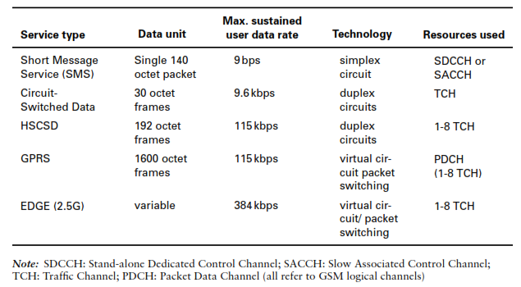

Table 1 Comparison of GSM data service

The use of CDMA technology began in the United States with the development of the IS-95 standard in 1990. The IS-95 standard has evolved since to provide better voice services and applications to other frequency bands (IS-95A), and to provide higher data rates (up to 115.2 kbps) for data services (IS-95B). To further improve the voice service capability and provide even higher data rates for packet and circuit switched data services, the industry developed the cdma2000 standard in 2000. A CDMA high data rate (HDR) system was developed by Qualcomm. The CDMA-HDR (now called 3G 1X EV-DO, [3G 1X Enhanced Version Data Only]). The 3G 1X EV-DO can transmit data in burst rates as high as 2.4 Mbps with 0.5 to 1 Mbps realistic downlink rates for individual users. The uplink design is similar to that in cdma2000. Furthermore, the 3G 1X EV-Data and Voice (DV) standard was ﬁnalized by the TIA and commercial equipment developed and deployed. 3G 1X EV-DV can transmit both voice and data trafﬁc

on the same carrier with peak data throughput for the downlink being conﬁrmed at 3.09 Mbps.

Table 2 lists the maximum data rates per user that can be achieved by various systems under ideal conditions. When the number of users increases, and if all the users share the same carrier, the data rate per user will decrease. One of the objectives of 3G systems is to provide access “anywhere, any time.” However, cellular networks can only cover a limited area due to high infrastructure costs. For this reason, *satellite* systems have formed an integral part of the 3G networks. Satellite have provided extended wireless coverage to remote areas and to aeronautical and maritime mobiles. The level of integration of satellite systems with the terrestrial cellular networks requires mobiles to be dual mode terminals to allow communications with orbiting satellite and terrestrial cellular networks. Low Earth orbit (LEO) satellites are mostly used for providing worldwide coverage. Currently several LEO satellite systems are being deployed to provide global telecommunications.

